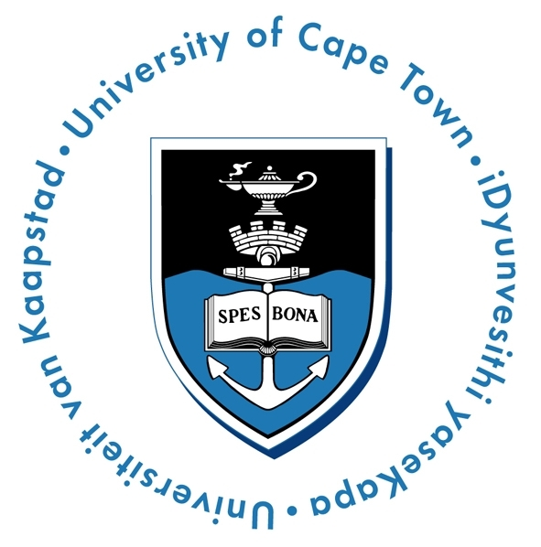

Media Statement 06 September 2007

UCT to confer honorary degree to Aung San Suu Kyi on International Human Rights Day

UCT is pleased to announce that it will confer on Aung San Suu Kyi an honorary degree – Doctor of Laws honoris causa, on 10 December this year at a graduation ceremony – this is also International Human Rights Day.

Suu Kyi, the 1991 Nobel Peace Laureate, has been detained for a number of years since 1989 and her movements restricted with each brief lifting of her detention. She remains a powerful figure worldwide for her non-violent protest for democracy and human rights for the Burmese people. As leader of the main opposition, the National League for Democracy (NLD) won 82% of the parliamentary seats in the 1990 national elections in Burma. The NLD was sadly declined office by the military which ignored the results, but Suu Kyi continues to be seen as the answer to the termination of military rule in her country. She is also the only Nobel Peace Laureate without freedom, and has called for countries to “use their liberties to promote Burma’s”.

We acknowledge Suu Kyi as an extraordinary example of the sheer strength, for her wealth of knowledge, for her perseverance and as a symbol of determination of women all over the world. Through Suu Kyi’s example, there is hope for millions of the down-trodden around the world.

Given the stringent conditions of her house arrest, Suu Kyi will not be able to travel to South Africa to receive the honorary degree. In her absence, fellow Nobel Peace Laureate, Archbishop Emeritus Desmond Tutu will receive the award on her behalf. Archbishop Tutu has been instrumental as a powerful international voice for the liberation of the Burmese people, particularly the release of Aung San Suu Kyi, and he has displayed his commitment to this fight by continually calling for the promotion of political dialogue that will lead to peace, freeing political prisoners and stopping attacks against Myanmar’s ethnic minorities.

By accepting this honorary doctorate, we will be recognising Aung San Suu Kyi’s commitment to the freedom of her country’s people. We honour her personal sacrifice for her beliefs.

Professor Njabulo S. Ndebele
Vice-Chancellor and Principal
University of Cape Town
Issued by:
Communications and Marketing Department – University of Cape Town
For further queries, please contact Ms. Dineo Noganta at Tel. +27 21 – 650 5674 or dineo.khechane@uct,ac,za

