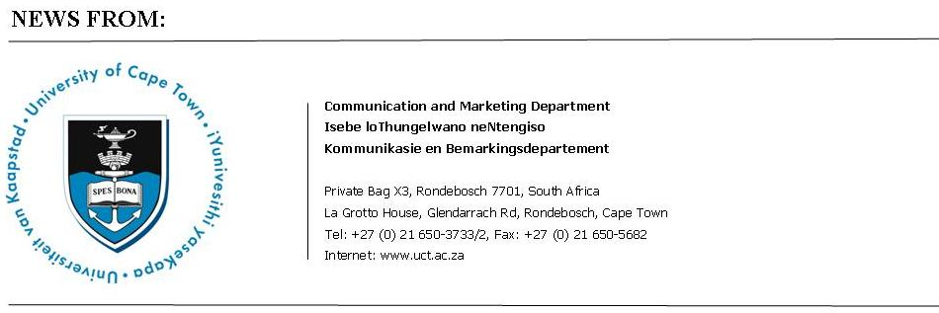

10 June 2009
Bumper numbers to be capped at UCT winter graduations

Seventy-eight PhD graduates are among 1273 students who will graduate in three ceremonies on Thursday and Friday this week (June 11 and 12).
The winter graduation programme will begin on Thursday night with degrees being conferred on 359 students in the Graduate School of Business, among 627 graduands in the faculty of commerce.
On Friday morning, the remaining commerce graduands will be capped, together with 209 students from the faculty of humanities.
In the afternoon, the university will confer degrees on graduands in the faculties of health sciences (109 students), law (92), science (101) and engineering and the built environment (134).
All ceremonies take place in Jameson Hall.
The PhD counts for the various faculties are: 23 for science, 20 for humanities, 14 for health sciences, 12 for commerce, six for engineering and the built environment, and three for law.
Commenting on the mid-year ceremonies, UCT vice-chancellor Dr Max Price says graduation reflects the perseverance of students presented with a rigorous academic environment and often significant personal challenges.
“Our students often overcome great personal hardship to achieve these milestones and the graduation is an opportunity to celebrate their achievements.
“The high numbers of PhD graduates across faculties is reflective of our vision to be a world-class research-led institution.”
The university will also confer an honorary doctorate on Prof Gavin Mooney, a leading health economist, at Friday afternoon’s ceremony.
The citation for the honorary doctorate conferred on respected educationalist Richard Dudley, who passed away recently, will also be read at the morning ceremony. Due to his failing health, the degree was conferred on Mr Dudley at his home earlier this year.
The director of Michaelis School of Fine Art, Prof Pippa Skotnes, will receive the book award for The Archive of Wilhelm Bleek and Lucy Lloyd, Claim to the Country. She will be joined by Prof Nigel Penn from the department of historical studies, who will receive the award for his book, The Forgotten Frontier.
Activist and retired Anglican bishop of Grahamstown, Dr David Russell, will receive the Medal of Convocation.
There are 22 996 students registered at UCT this year. Last year, the university graduated 1158 students in June and 4405 in December,

Ends

Issued by:

Ray Hartle
Media Manager
Communication and Marketing Department
University of Cape Town
La Grotto House, Glendarrach Road
Rondebosch
Tel: (021) 650 5674 Fax (021) 650 5628
Cell: 083 4100312
UCT speed dial 8521
E-mail: Ray.Hartle@uct.ac.za
Website: www.uct.ac.za

