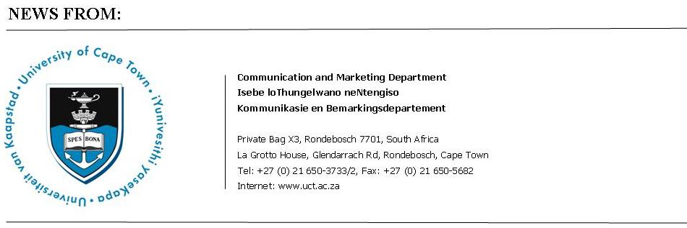

2 September 2009

UCT researchers set new benchmark in NRF ratings

Eleven researchers from UCT had their A ratings confirmed by the National Research Foundation at a ceremony on 1 September 2009 – an unprecedented number from a single South African university in one year and more than half of all the A ratings awarded.
UCT Vice-Chancellor Max Price said: “I congratulate the individuals who have maintained or improved their international standing in the research community. It is also a remarkable achievement for the University to have recruited, facilitated and retained so many leading scientists. It positions the university as a leader in attracting post-graduate students and research projects and grants, and in enabling us to pursue our mission of producing the next generation of academics for South Africa and the continent.
It is this commitment to quality that establishes UCT firmly among the community of world-class, research-led universities.”
In addition, the NRF has honoured author, scholar and former UCT Vice-Chancellor Professor Njabulo Ndebele with the Lifetime Achievement Award. The foundation referred to Professor Ndebele as “one of South Africa’s great literary icons” for his “incisive political commentaries [that] critically reflected on the tone and tenor of the South African struggle for liberation.”
Dr Price said: “UCT is doubly proud that Emeritus Professor Ndebele, named by the NRF as a leading light among South African writers, continues to work as an academic at UCT having also contributed his wisdom and leadership to UCT as its former Vice-Chancellor.”
ENDS

2009 NRF A and P Rated Researchers (newly rated and re-rated )

Rating | Title | Initials | Surname | Department
A1 | Prof | WJ | Bond | Department of Botany
A1 | Prof | JWA | Cleymans | Department of Physics
A1 | Prof | MC | Kew | School of Medicine
A1 | Prof | B | Warner | Department of Astronomy
A2 | Prof | ED | Bateman | Department of Medicine
A2 | Prof | GM | Branch | Department of Zoology
A2 | Prof | GFR | Ellis | Mathematics and Applied Mathematics
A2 | Prof | JM | Farrant | Department of Molecular and Cell Biology
A2 | Prof | R | Mesthrie | Department of English & Linguistics
A2 | Prof | ML | Solms | Department of Psychology
A2 | Prof | CL | Vaughan | Department of Human Biology

Issued by: UCT Communication and Marketing Department

Ray Hartle
Media Manager
Tel: (021) 650 5674 Fax (021) 650 5628
Cell: 083 4100312
E-mail: Ray.Hartle@uct.ac.za

Patricia Lucas
Media Liaison Officer
Tel: (021) 650 5428 Fax (021) 650 5628
Cell: 076 292 8047
E-mail: Pat.Lucas@uct.ac.za

