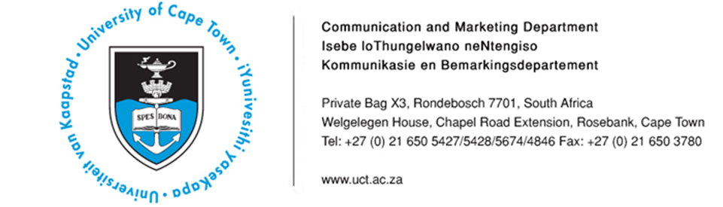

01 April 2014

Upcoming UCT events
- Shifting focus - Addressing the neglected pandemic of injury: An inaugural lecture by Professor Lee Wallis on the pandemic that kills millions though little attention is paid to addressing the issue
- “Climate Change 2014: Impacts, Adaptation and Vulnerability”: An open discussion on key insights and challenges from this assessment report
- Do HIV conferences actually translate into practical action? An interactive session on HIV, science and community engagement: how to ensure that conferences go beyond the word and make a difference in the global response to HIV
Date | Event/Topic | Highlights/Speakers | Contact
2 April | Inaugural lecture: “Shifting focus: Addressing the neglected pandemic”  Time: 17h30  Venue: Student Learning Centre Lecture Theatre, Anatomy Building, Faculty of Health Sciences | Delivering his inaugural lecture, Professor Lee Wallis will argue that even though injury kills around 5,8 million people a year, very little attention is paid to this issue in terms of studies and funding. Professor Wallis is the Head of the Division of Emergency Medicine at both the University of Cape Town and Stellenbosch University. He is also the Head of Emergency Medicine for the Western Cape Government.  He says over the past 20 years a huge amount of resources has poured into what are termed vertical programmes, addressing single diseases such as HIV, TB or Malaria. He adds that according to the World Health Organization (WHO), HIV, TB and Malaria kill around 4,2 million people a year.  Professor Wallis says: “These programmes have clearly been very beneficial for those patients, but they do come at a wider cost. There is evidence that where countries put significant resources into vertical programmes, the rest of their health systems suffers. Injury has received almost no attention despite the argument that it is a bigger problem than HIV, TB or Malaria. No global funds or large research grants are allocated to fight it, and the WHO dedicates very little resources to it. Injury is not part of the United Nations’ Millennium Development Goals or other public health interventions. In South Africa, it receives almost no research funding from any of the national bodies, and is given no prominence at universities.” | Kemantha Govender  Tel: 021 650 5672  Cell: 084 737 6522  Kemantha.Govender@uct.ac.za
2 April | African Climate and Development Initiative (ACDI) Open Discussion Meeting: The Working Group II contribution to the Intergovernmental Panel on Climate Change (IPCC) 5th Assessment Report (AR5)  Time: 17h00 – 19h00  Venue: Kramer Law Lecture Theatre 2, Middle Campus | Key insights and challenges from the recently released IPCC 2014 Assessment Report, “Climate Change 2014: Impacts, Adaptation and Vulnerability”, will be discussed at an open meeting hosted by the ACDI. The meeting will see presentations from a number of authors who contributed to various chapters of the AR5’s Working Group II section.  Speakers include:  - Dr Guy Midgley - Adaptation opportunities, constraints and limits (Chapter 16)  - Penny Urquhart - Africa (Chapter 22)  - Katharine Vincent - Rural Areas (Chapter 9)  - Debra Roberts - Urban Areas (Chapter 8)  - Professor Bruce Hewitson - Regional Context (Chapter 21) | Kemantha Govender  Tel: 021 650 5672  Cell: 084 737 6522  Kemantha.Govender@uct.ac.za
4 April | Interactive session on HIV, science and community engagement: “Stepping up the pace: Community action and continuing the scientific conversation”  Time: 11h00 - 12h00  Venue: Mafeje Room, Second Floor, Bremner Building, Middle Campus | The session is hosted by the International AIDS Society as well as the Desmond Tutu HIV Foundation and HIV/AIDS Coordination Unit (HAICU) at UCT.  Looking at the scientific and community engagement around leading political and scientific HIV conferences, this event will focus on how to ensure that these conversations go beyond the word and translate into practical action that makes a difference in the global response to HIV. It promises to be a provocative and interactive discussion.  Keynote speakers include:  - Professor Olive Shisana, CEO of the Human Sciences Research Council, and Principal Investigator and Co-chair of the 21st International AIDS Conference (AIDS 2016)  - Professor Linda-Gail Bekker, Professor of Medicine and Deputy Director of the Desmond Tutu HIV Centre, UCT  - Cal Volks, Director of HAICU  - Dr Lucy Stackpool-Moore, AIDS 2014 Communications Coordinator | Kemantha Govender  Tel: 021 650 5672  Cell: 084 737 6522  Kemantha.Govender@uct.ac.za

ENDS

Issued by: UCT Communication and Marketing Department

Kemantha Govender
Media Liaison Officer
Communication and Marketing Department
University of Cape Town
Welgelegen, Upper Chapel Road Extension, Rosebank
Tel: (021) 650 5672 Fax: (021) 650 3780
Cell: (084) 737 6522
E-mail: kemantha.govender@uct.ac.za
Website: www.uct.ac.za

